MULTI LINE INSURANCE POLICY
AND CLAIMS MANAGEMENT
SYSTEM

Milestone 1: Core Data Model & Policy Configuration ( Proof)

TEAM 7 MEMBERS :
NAME : R.HARIHARAN
ROLL NO : 822223104033
NM ID: 89EB08A5DEDC3B48B3349612B3B64218
EMAIL ID : hhariharan708@gmail.com

NAME : T.MUTHAMILSELVAN
ROLL NO : 822223104038
NM ID: 6C4BDAACAD9BB1FB31A47784B2502B96
EMAIL ID : t.muthamil555@gmail.com

Name :C.T.BHUVANESH
ROLL NO :822223104042
NM ID : DB1E37315FFD9B494E546AB8931A54DA
EMAIL ID : bhuvaneshthi@gmail.com

User Story1: Creation of custom objects
1. Create Policy custom object:
- Go to setup, Click on object Manager.
- Click on create and select custom object.
- Fill the following details:
- Label: Policy
- Plural Label: Policies
- Object Name: Auto Populated
- Record Name: Policy Number
- Data type: Auto Number
- Format: P - {0000}
- Starting Number: 1
- Under optional features:
- Allow Reports, Activities and Track field History
- Under Deployment Status:
- Select the deployed radio button.
- Under Search Status:
- Check the Allow Search checkbox.
- Click on save.

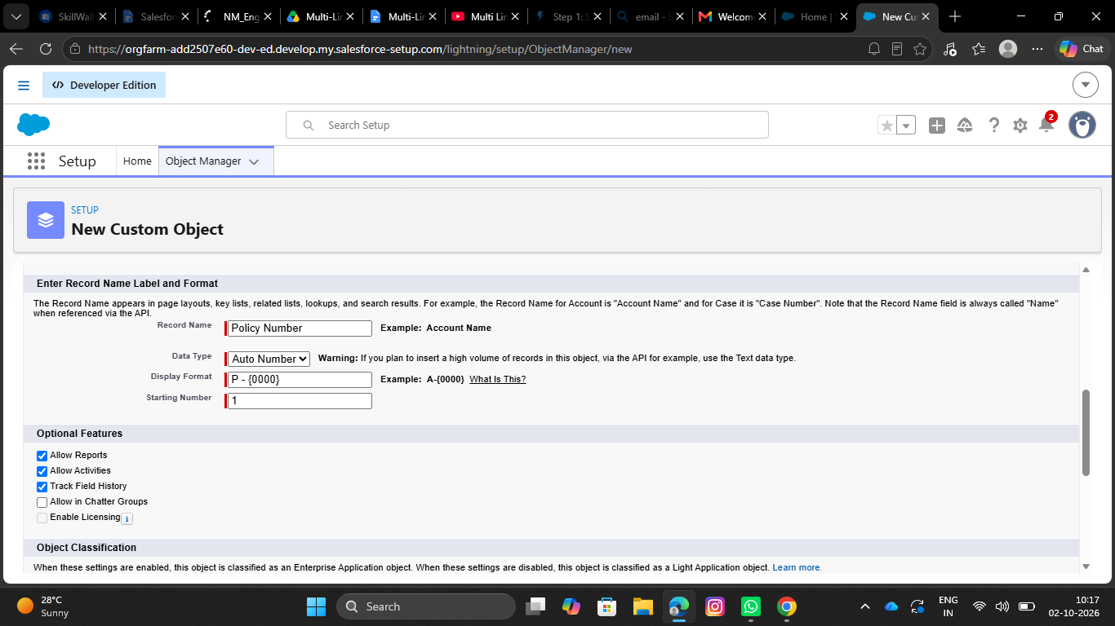
- Define Record Types on Policy Object:
- Go to setup, Click on Object Manager.
- Search for Policy objects and click on Policy__c.
- In the left side panel, click on the record types.
- Click on New.
- Fill out the following details:
- Select the existing record type as Master.
- Give record type label as “Auto”
- Record Type Name will be auto populated.
- Give a meaningful description.
- Check the active checkbox.
- Check the Make Available checkbox for all the profiles.
- Click on Next.
- It will redirect to the Assign page layouts page, Leave everything as is, and click on save.

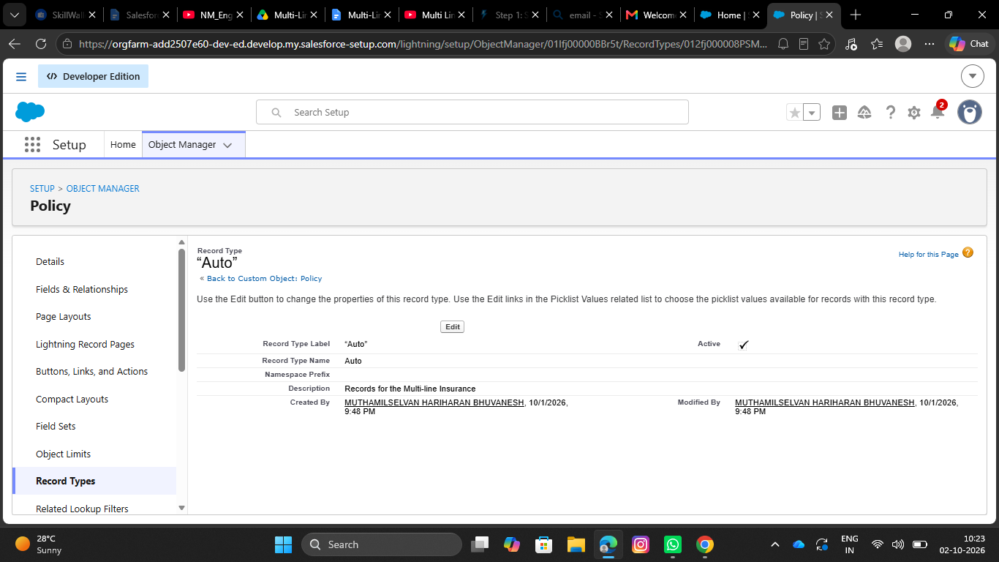

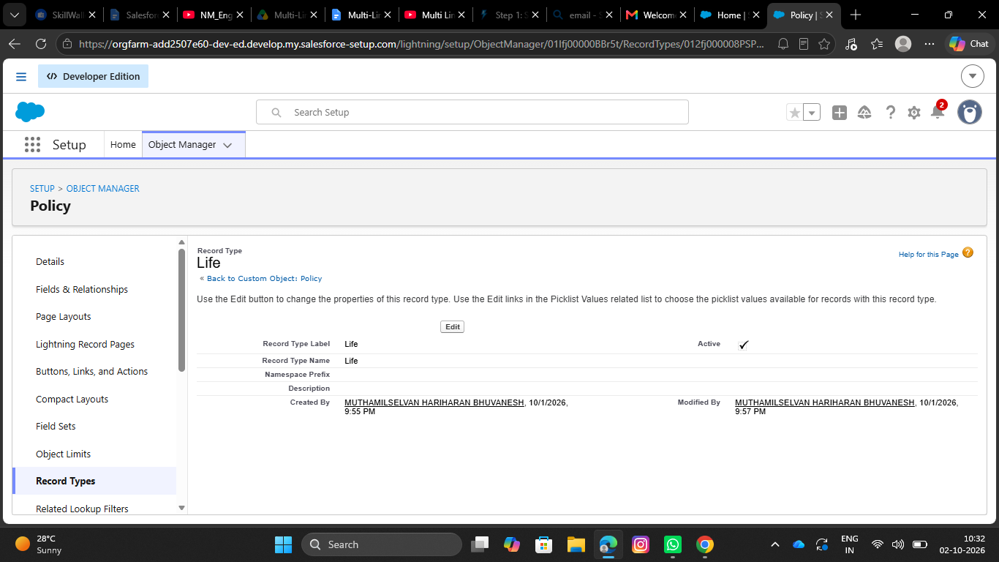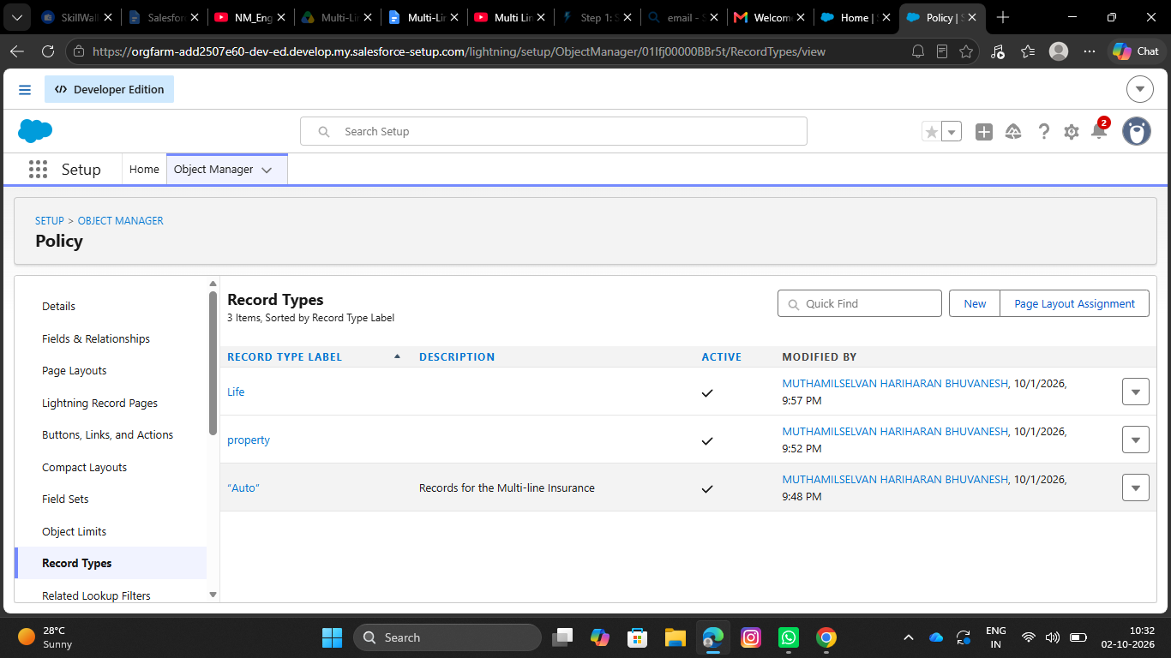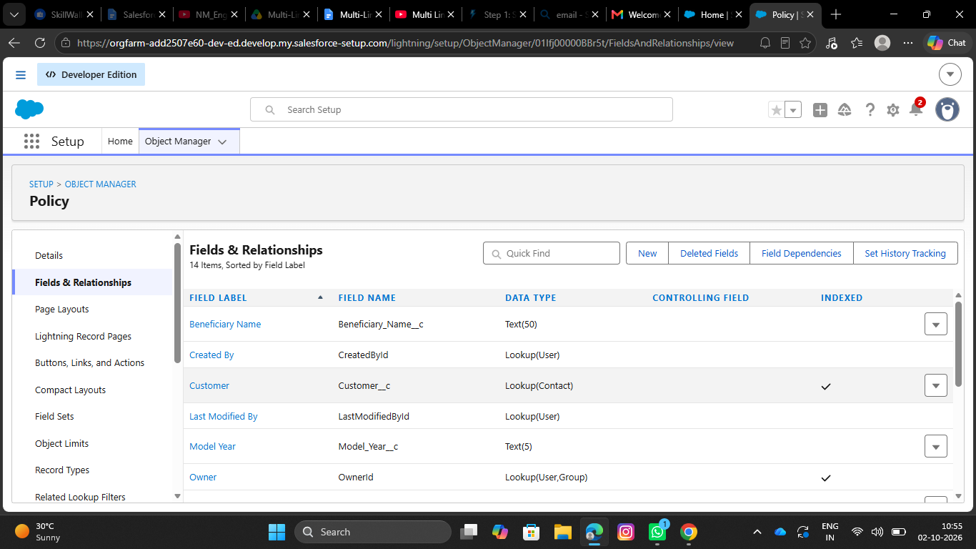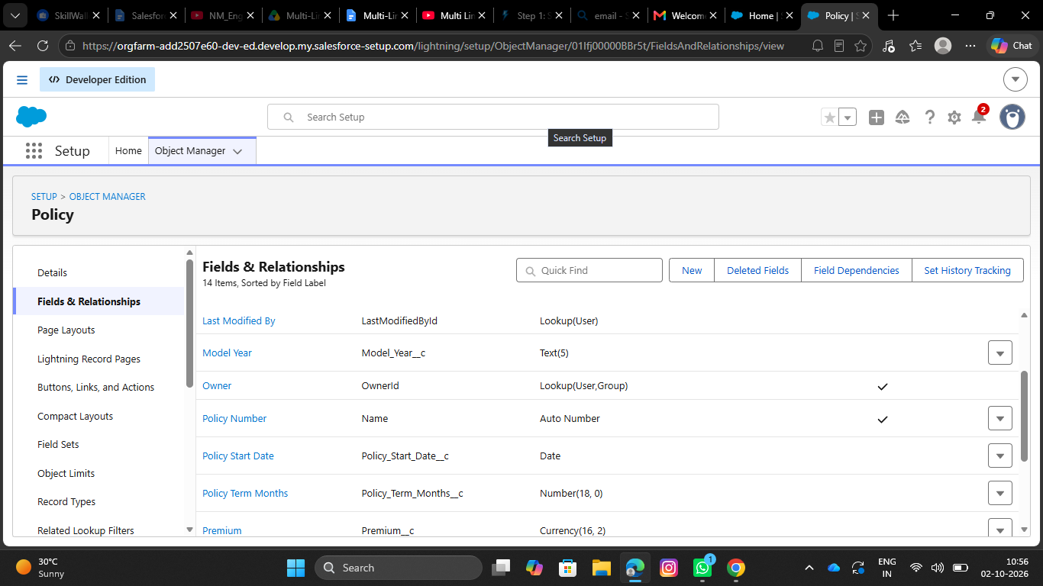
- 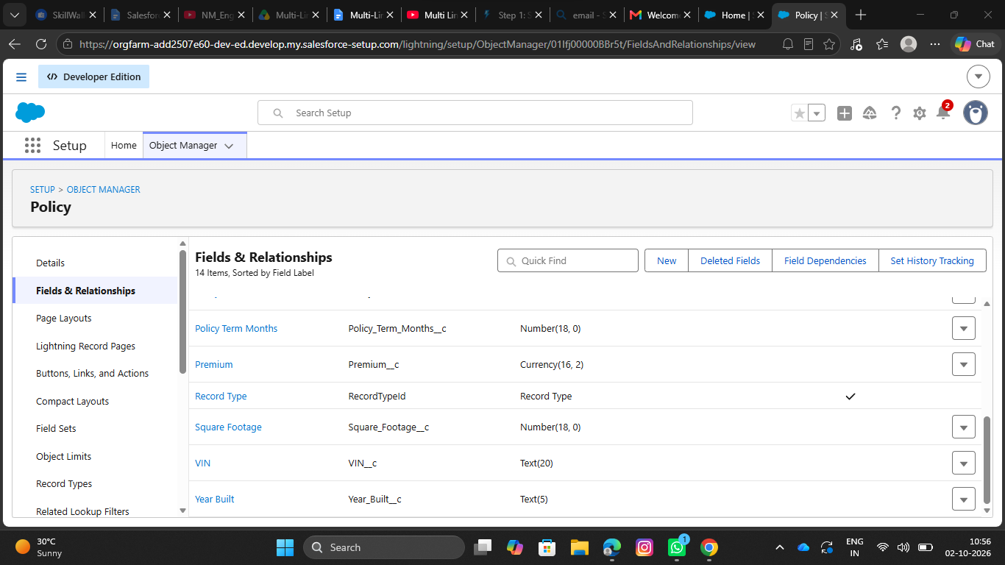Repeat the same steps for creating the property and life record types as well.

Create Field Sets for policy specific data:
- Go to setup, Click on Object Manager.
- Search for Policy object and click on Policy__c.
- In the left side panel, click on the Field Sets.
- Click on New.
- Fill out the following details:
- Field Set Label as Vehicle
- Field Set Name will be Auto populated.
- Where is this used: In the policy object.
- Click on save.
- Click on the field set you have just created and it will redirect to the page layout setup.
- Drag VIN, and model year fields to the field set and click on save.

- 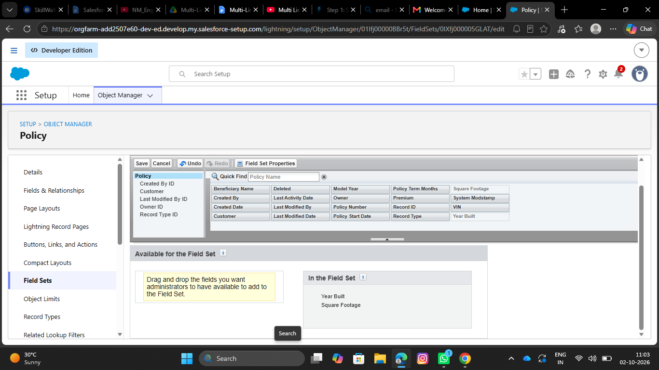Repeat the same steps for creating the property and life Field sets as well.

3.1 Property FieldSet Requires:
- Square footage
- Year Built

3.2 Life FieldSet Requires:
- Beneficiary Name
- Policy Term Months

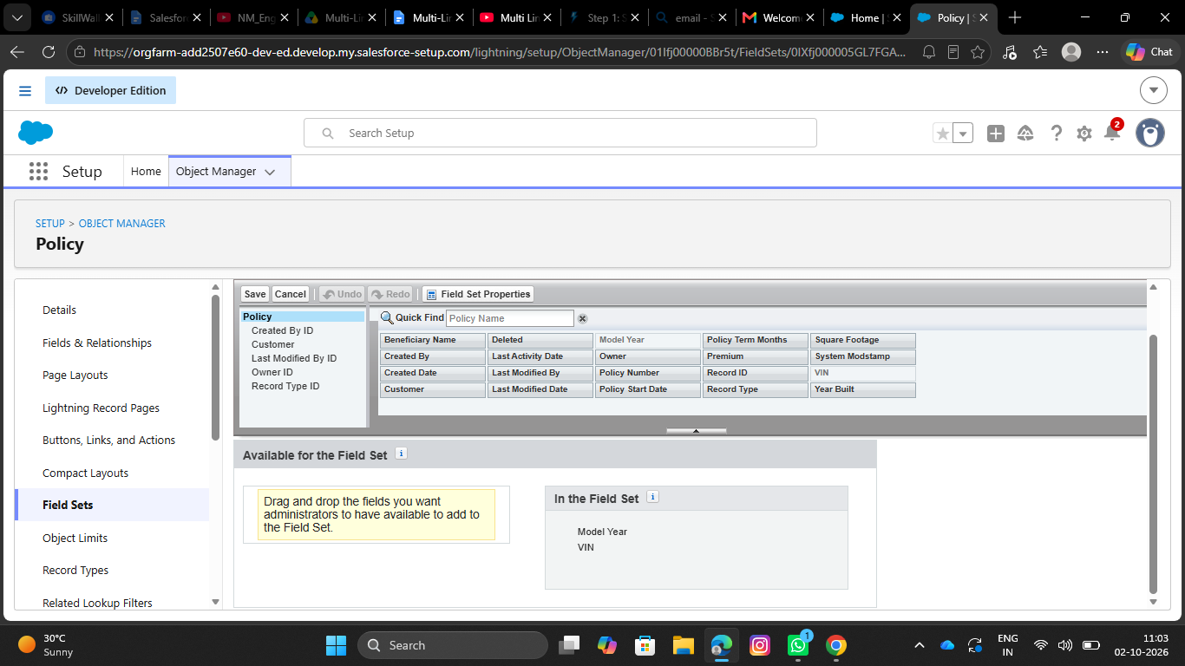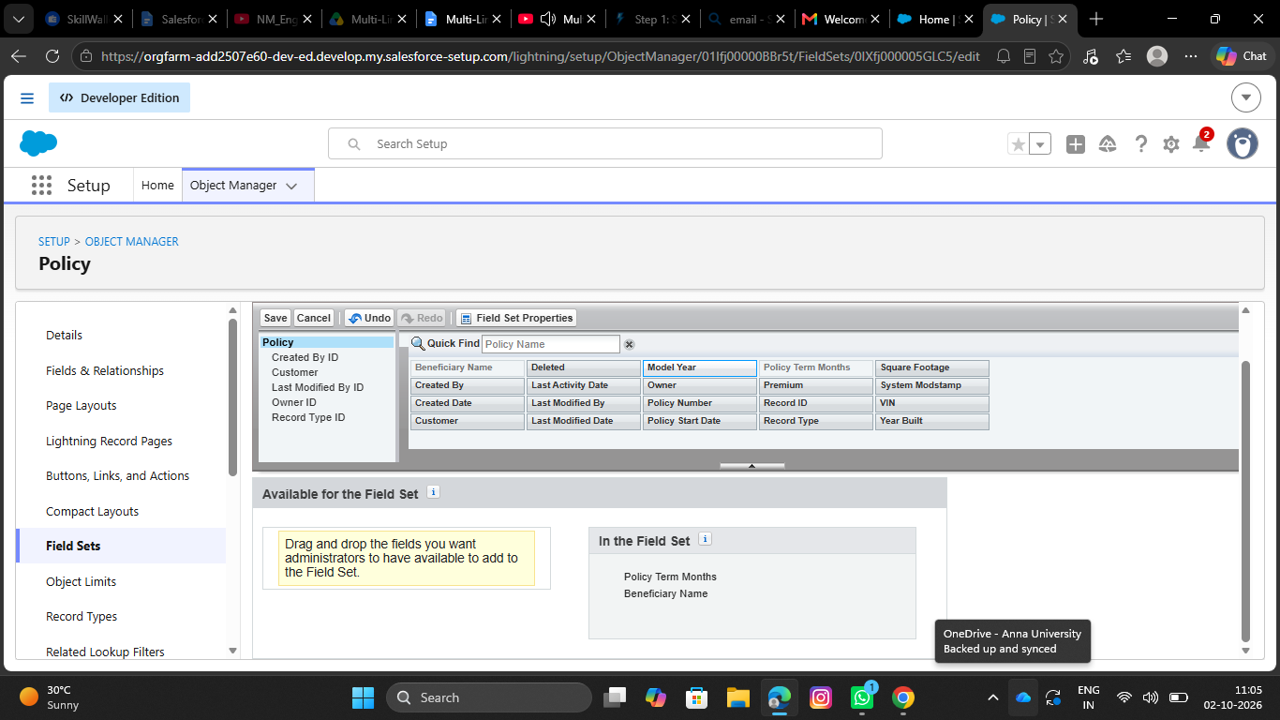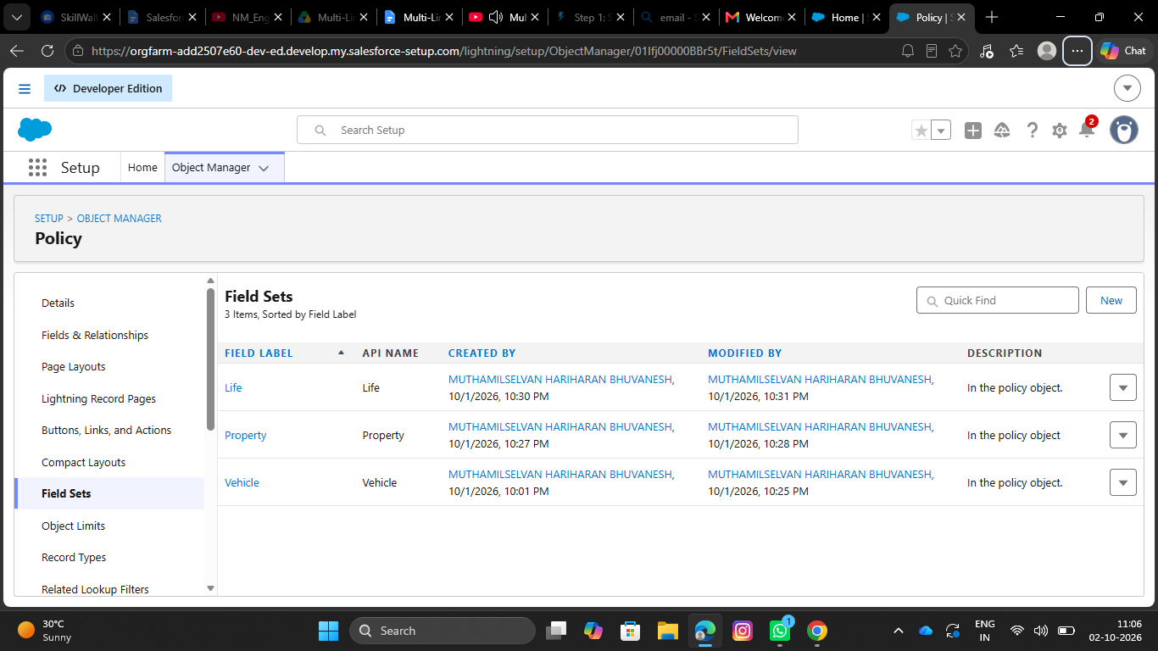 4. Create Fields in the Policy Object:
S.No | Name of the Field | Data Type | Required
1 | Beneficiary Name | Text(50)
2 | Customer | Lookup(Contact)
3 | Model year | Text(5)
4 | Policy start date | Date
5 | Policy term month | Number(18, 0)
6 | Premium | Currency(16, 2)
7 | Square footage | Number(18, 0)
8 | VIN | Text(20)
9 | Year built | Text(5)

- Create Claim custom object:
- Go to setup, Click on object Manager. Currency(16, 2) Number(18, 0) Text(20) Text(5)
- Click on create and select custom object.
- Fill the following details:
- Label: Claim
- Plural Label: Claim
- Object Name: Auto Populated
- Record Name: Claim Number
- Data type: Auto Number
- Format: C - {0000}
- Starting Number: 1
- Under optional features:
- Allow Reports, Activities and Track field History
- Under Deployment Status:
- Select the deployed radio button.
- Under Search Status:
- Check the Allow Search checkbox.
- Click on save.

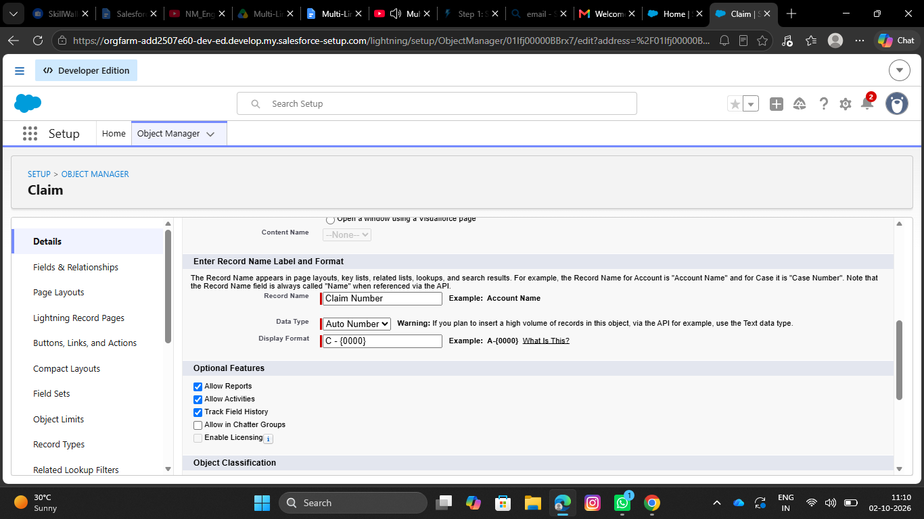
- 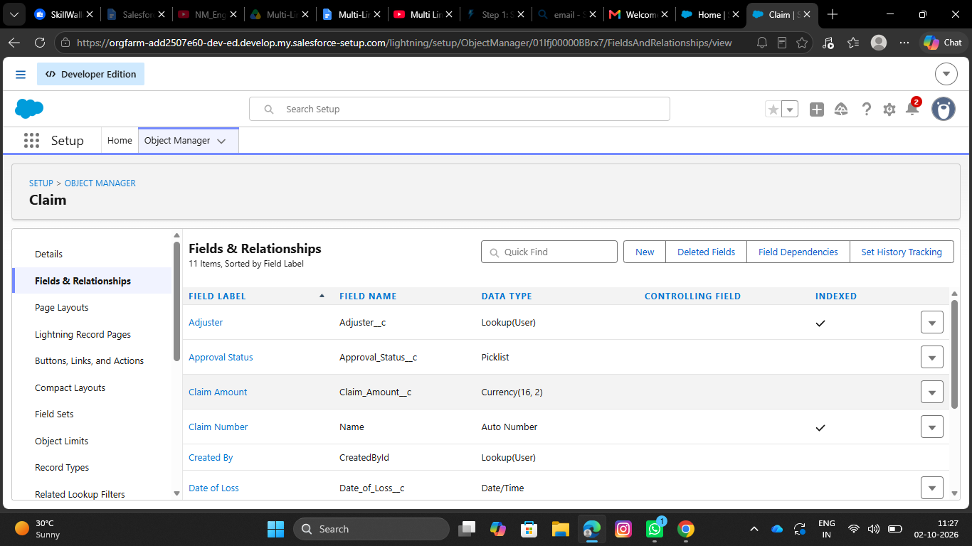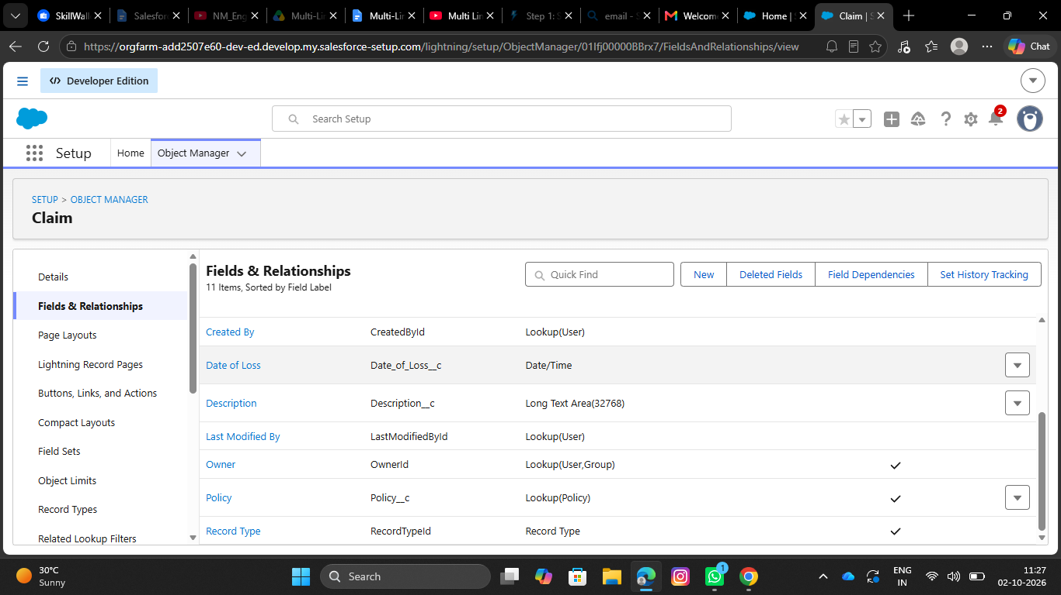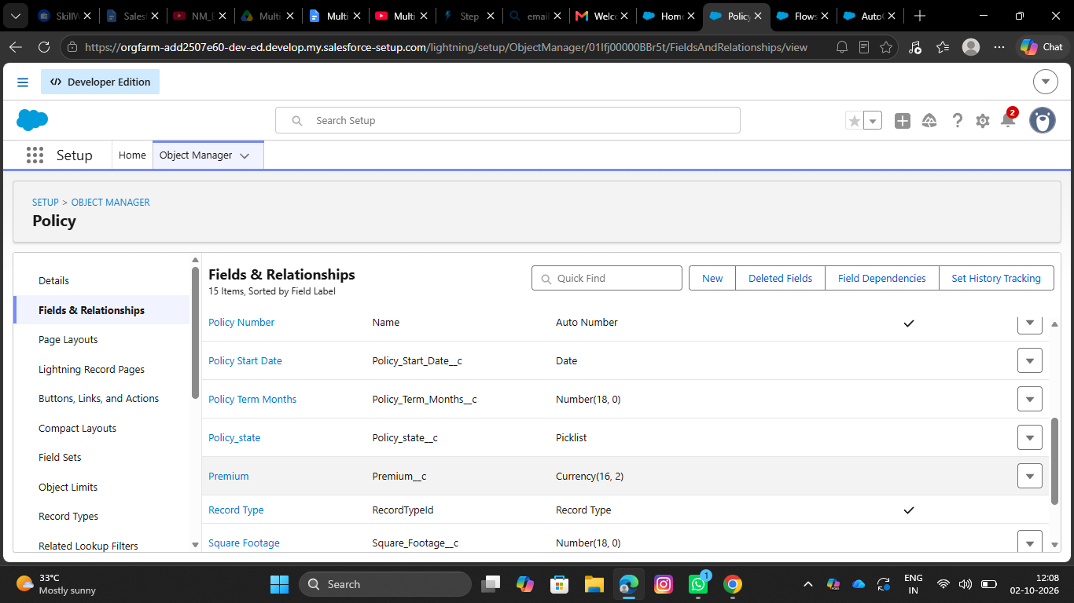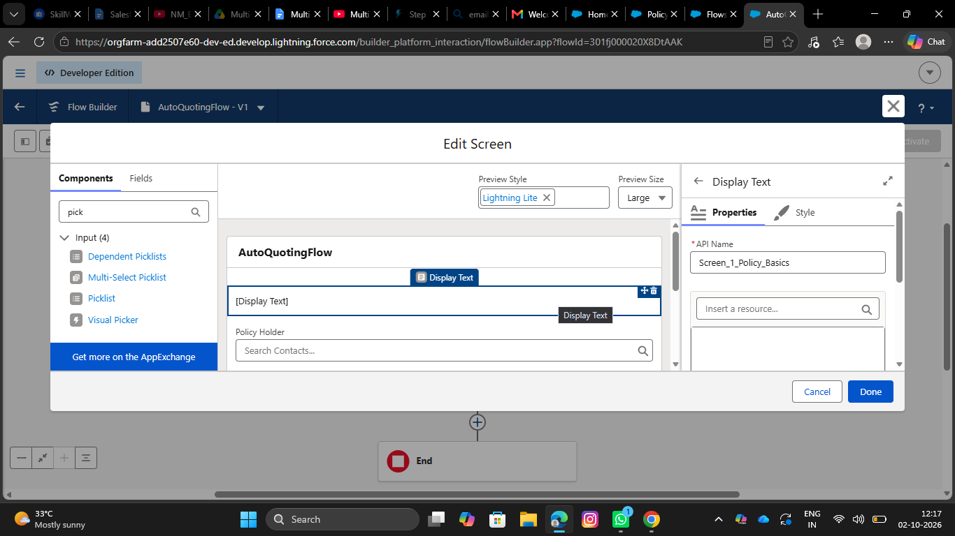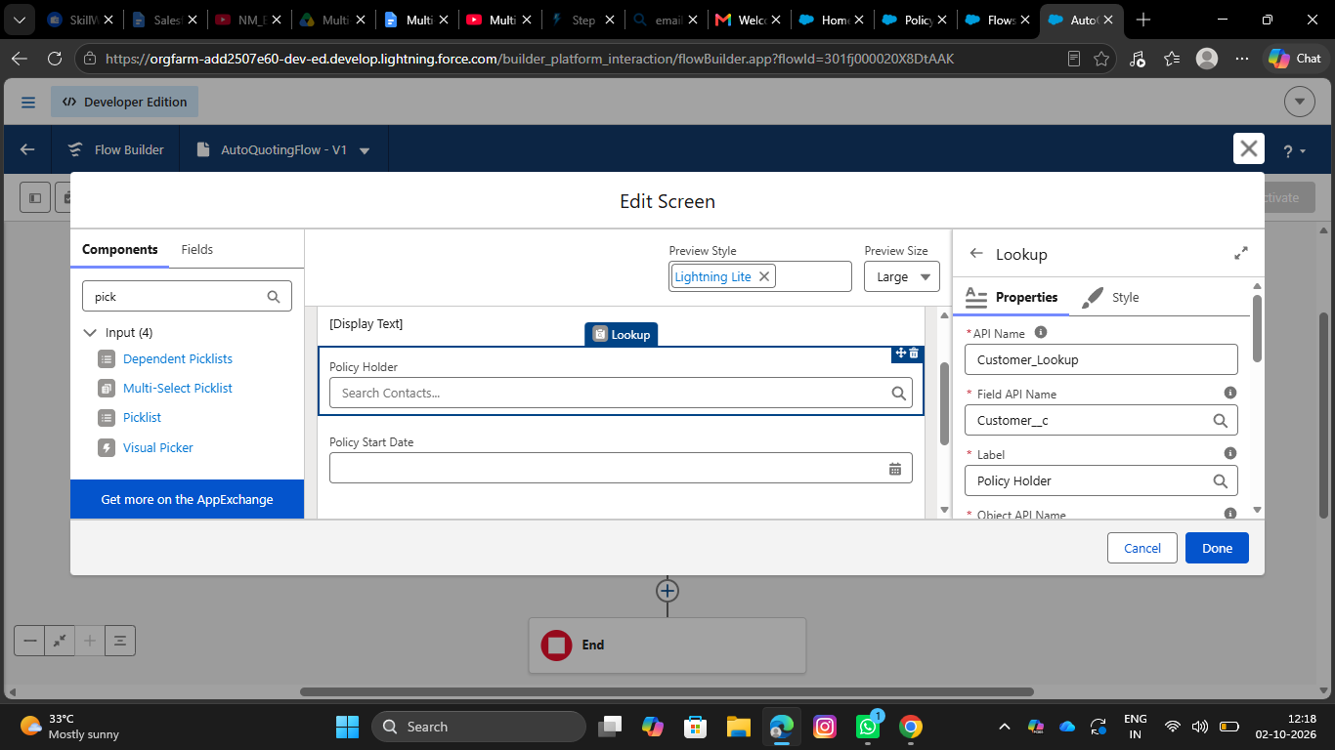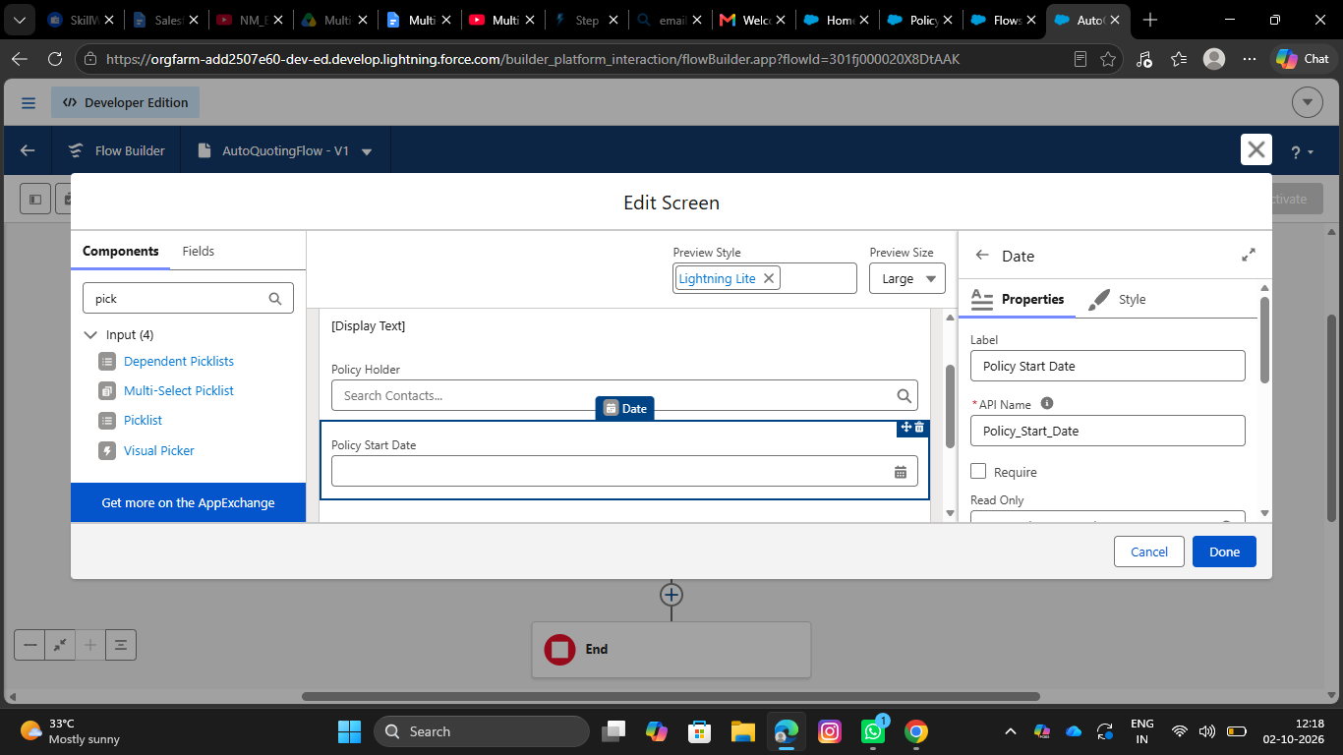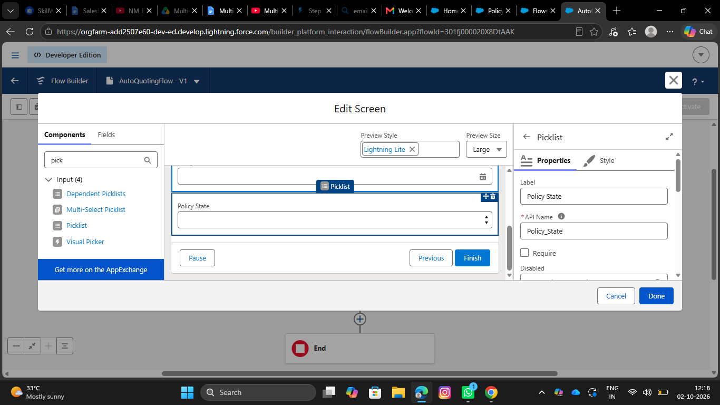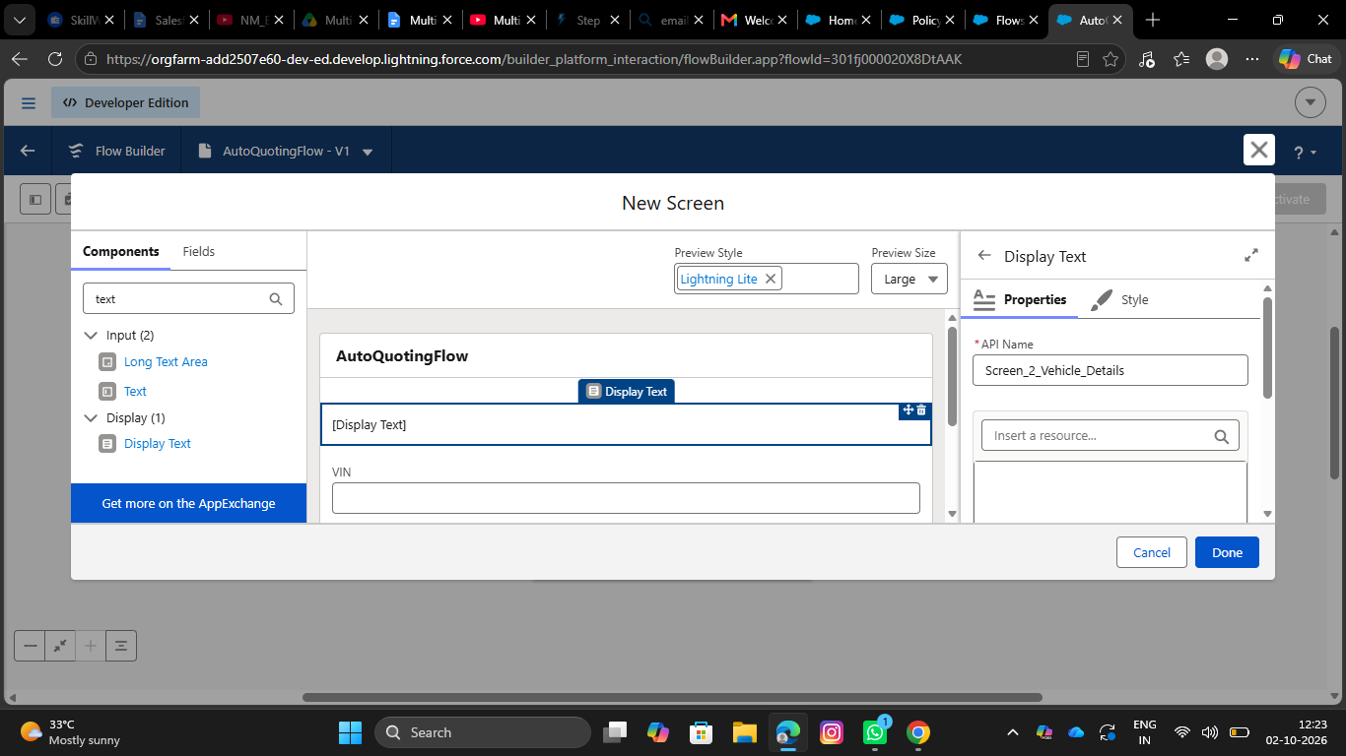6 .Define Record Types on Claim Object:
- Go to setup, Click on Object Manager.
- Search for Claim object and click on Claim__c.
- In the left side panel, click on the record types.
- Click on New.
- Fill out the following details:
- Select the existing record type as Master.
- Give record type label as “Accident”
- Record Type Name will be auto populated.
- Give a meaningful description.
- Check the active checkbox.
- Check the Make Available checkbox for all the profiles.
- Click on Next.
- It will redirect to the Assign page layouts page, Leave everything as is, and click on save. //Repeat the same steps for creating the property and life record types as well. 7. Create Fields in the Claim Object: S.No 1 2 Field Name Adjuster Approval Status Data Type Lookup(User) Required Picklist(New, Submitted for Approval, Approved, Rejected) 3 4 Claim Amount Date of Loss Currency(16, 2) Date/Time

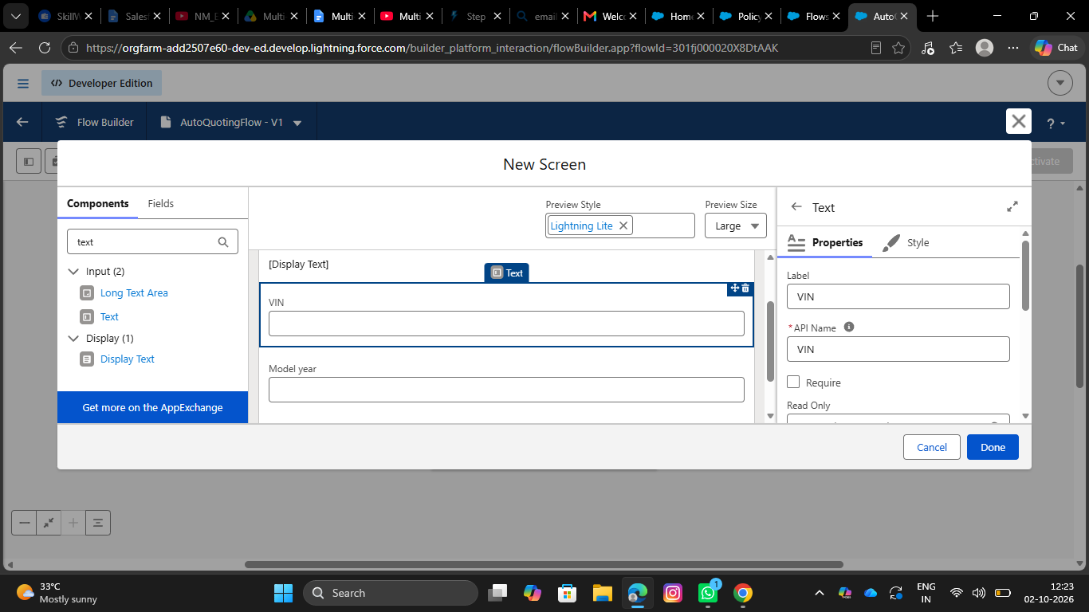7 . Create an AutoQuoting Screen Flow
- Go to setup, Search for flows in the quick find box.
- Click on flows and click on new flow.
- Select Screen Flow and Click on Create.
- Add Get Records Element immediately after the start element.
- Give Label as Get Vehicle RT ID
- Api Name will be auto populated
- Select Record Type for Object
- For Conditional Requirements, Select All Conditions are met
- The Conditions include:
- sObject Type Name Equals Policy__c
- And
- Record Type Name Equals Auto
- Add Screen Element immediately after the Get Records Element
- Give the label as New Auto Policy Quote - Basic Information
- API Name will be auto populated.
- Drag the display text component into the flow canvas
- Give the API Name as Screen_1_Policy_Basics
- Drag the Lookup Component into the Canvas, Give API Name as Customer Lookup, Field API Name as Customer__c, Label as Policy Holder, ObjectApiName as Policy__c
- Drag Date component into the canvas, Give Label as Policy Start Date, API Name will be auto populated.
- Drag the picklist component into the canvas, Give the label as Policy State, API Name will be auto populated, For Choice, Create a new Resource, Resource Type should be Picklist Choice Set, Give the API Name, Select the Policy for Object, Select Picklist as Datatype, Select Policy State as Field and Click on save
- Click on Done

- 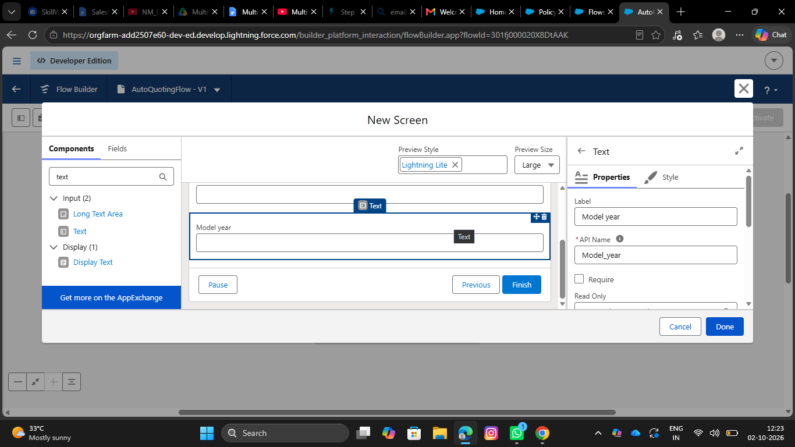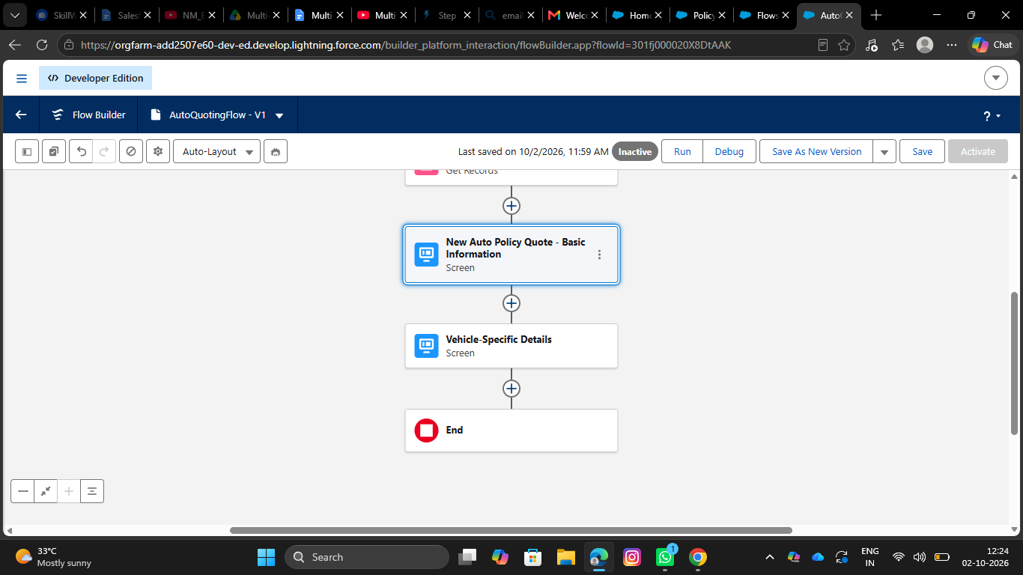
- Give the label as Create Draft Policy, API name will be auto populated
- Store field values manually
- Select the policy object
- Set fields for the policy object as shown below:
- Customer —> From Basic information screen-> Policy Holder -> Record ID
- Model Year—--> Vehicle information screen -> Model Year
- Policy Start Date —> From Basic information screen→Policy Start Date
- Policy State —> From Basic information screen —> Policy State
- RecordType ID —> From Get Vehicle RT Id —> RecordType ID
- VIN —> From Vehicle Information Screen —> VIN
- Check manually assign variables checkbox
- In the place of variable, create a new resource, Whose resource type is variable, API Name would be varPolicyId, Datatype would be Text, Click on Done.
- Save the flow with AutoQuotingFlow
- Activate the flow

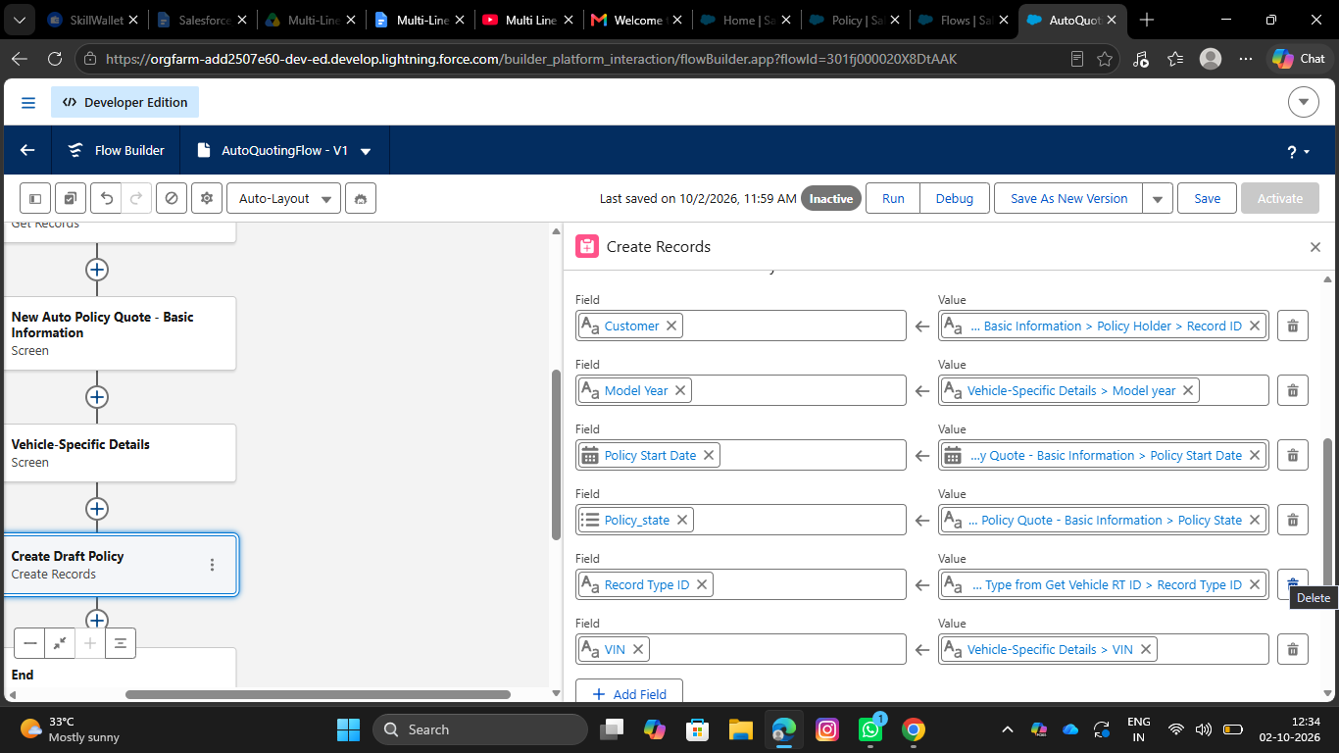

- 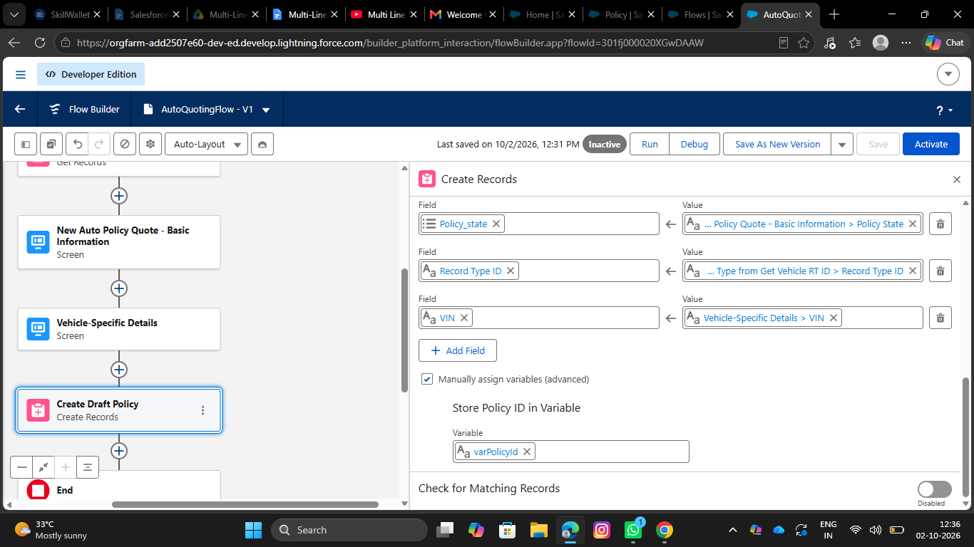8 .Create Validation Rule on Policy Object:
- Go to object manager, Search for the policy object and click on policy object
- In the left side panel, scroll down and find validation rules and click on it
- Click on New
- Give the rule name as VIN_Must_Be_17_Characters
- Check the active checkbox
- Write the following formula in the formula editor ○ AND( RecordType.DeveloperName = "Auto", LEN( VIN__c )<> 17)
- For error message, The Vehicle Identification Number (VIN) must be exactly 17 characters long for Auto Policies.
- Select error location as field and select VIN field
- Click on Save
